

Document Control
Thomson Medical D365 CRM
Phase 1 Functional Specification
Document Information
 | Information
Document Owner | Haixia Liang
Issue Date | 10/02/2026
Last Saved Date | 20/02/2026
File Name | Thomson Medical TMPL Phase 1 – Functional Specification

Document History
Version | Issue Date | Changes
0.01 | 10/02/2026 | Initial Version
0.02 | 20/02/2026 | Problem statement, workaround, estimated mandays per solution updated. New project plan and low-fidelity dashboard design added.
0.03 | 27/02/2026 | Elaborated the solution and objectives based on the comments from Kuok given on 23 Feb.
0.04

Document Approvals
Role | Name | Signature | Date
Project Directors  Deeeplabs Pte Ltd | Dex Lim
Project Manager  Deeeplabs Pte Ltd | Hadi Perdana
Business Analyst  Deeeplabs Pte Ltd | Haixia Liang
Business Analyst  Thomson Medical Group | Kuok Kim Chern

Table of Contents
1 Purpose 6
2 Background 6
2.1 Current End-to-End Process Overview 7
2.2 Identified Pain Points 8
2.3 Operational Characteristics 8
2.4 Current Challenges 8
3 Objectives 10
4.1 Core Platforms 11
5 Solution Scope 11
5.1 In Scope 11
5.2 Out of Scope 11
6 Future State (TO-BE) 12
6.1 Target Process 12
7 System Components 14
7.1 Dynamics 365 Customer Service (D365) 14
7.2 Power Automate 15
7.3 Shared Mailbox 15
8 Functional Requirements 15
8.1 CM-02 – Automated Case Tracking & Reminder System 15
8.1.1 Feature Overview 15
8.1.2 Functional Requirements 17
8.1.3 Type of Notification Scenarios 21
8.1.4 Notification Message Template 24
8.2 CM-03 – Post-Resolution Reply Detection 27
8.2.1 Feature Overview 27
8.2.2 High-Level Process Flow 27
8.2.3 Functional Requirements 27
8.2.4 Notification Message Template 28
8.3 CM-08 – Outstanding Actions Visibility 29
8.3.1 Feature Overview 29
8.3.2 Functional Requirements 29
8.4 CM-09 – Case Visibility 30
8.4.1 Feature Overview 30
8.4.2 Functional Requirements 31
8.4.3 Notification Message Template 32
9 Notification 33
9.1 Notification Mechanism 33
9.2 Teams Channel Configuration 33
9.3 Notification Routing Logic 34
10 Project Plan 34

Purpose
This document defines the functional requirements, expected system behaviour, and configuration specifications for automating the case management process using:
- Microsoft Dynamics 365 Customer Service
- Power Automate
- Exchange Shared Mailboxes
- Bridgette Integration Middleware
  - Acts as integration layer, responsible for orchestrating and managing data exchange between external communication channels and internal systems to D365
  - Referenced for context only; no changes or enhancements to the middleware are included as part of this implementation.

The document serves as:
- Build specification for the technical team
- Configuration reference for CRM and Power Automate
- Test basis for UAT

Background
Currently, patient enquiries and issues are submitted via Email, Web Form, or WhatsApp and are managed through a combination of CRM case records, shared mailboxes, manual email forwarding, Excel-based tracking, and manual follow-up reminders.
- The existing process relies heavily on manual intervention, including:
- Manual forwarding of cases to Business Units (BUs)
- Manual tracking of follow-ups in Excel
- Manual checks at predefined intervals (Day 3 / Day 7)
- Email-based coordination across shared mailboxes

Current End-to-End Process Overview
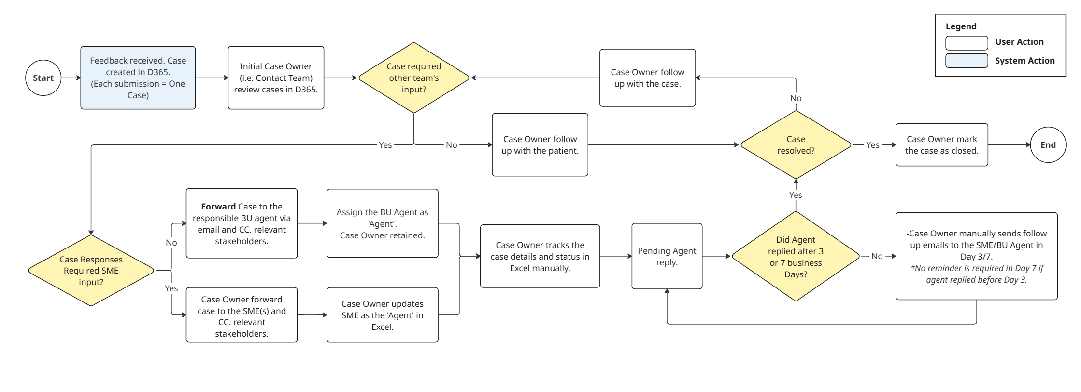
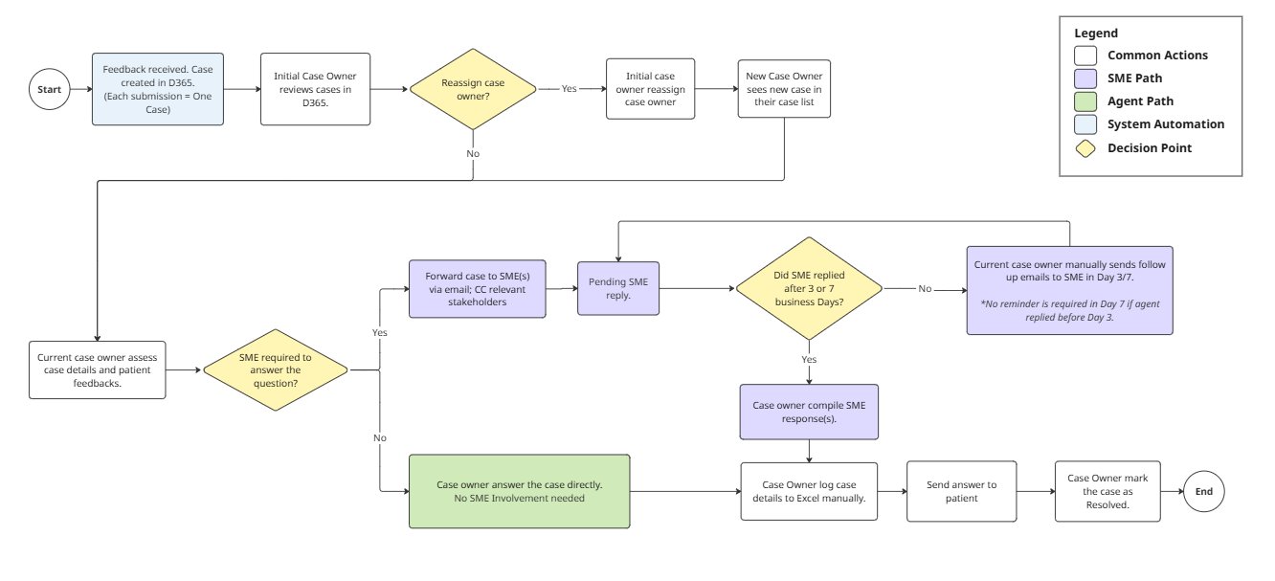AS-IS User Journey
At a high level, the current operational flow is as follows:
- Patient submits new enquiry via Email, Web Form or WhatsApp
- A new case is created in CRM and assigned to the case owner automatically.
- The Initial Case Owner reviews the case details.
- The Initial Case Owner reviews their case list manually, check if reassignment is needed.
- If reassignment is required (cases belongs to another business unit): The initial case owner changes the case owner to the appropriate team. The new case owner sees the case in their list.
Note: The initial case owner loses visibility of the case.
- If no reassignment required: The initial case owner retains the case and proceed.
- Current case owner evaluates if Subject Matters Expert (SME) is required to answer the patient’s question.
5A. SME Path – SME is required:
  - Case owner forwards the case to the relevant SME(s) via email. Manager is CC-ed in the email correspondence
  - Case owner awaits the SME’s reply and monitors for follow up.
  - Once the SME replies, the case owner compile response(s) and reply to the patient.

5B. Agent Path – SME is NOT required:
- Case owner answers the patient's question directly without SME involvement.
- The Case Owner manually tracks follow-up case details and status into Excel
- The Case Owner performs manual checks at Day 3 and Day 7 to chase responses.
- If no response is detected, follow up emails are sent by the case owner manually.
- A case is marked Resolved upon confirmation of resolution by the case owner. Note: Subsequent email responses related to a resolved case are allowed; however, the status will not be automatically updated.

Identified Pain Points
ID | Issue | Root Cause
CM-02 | Manual Excel Tracking | No automated follow-up tracking
CM-03 | No post-resolution detection | No automation monitoring mailbox for resolved cases
CM-08 | No outstanding visibility | No SLA indicators and operational views
CM-09 | Premature closure | Original case owner has no visibility on status changes after case reassignment

Operational Characteristics
The existing process relies heavily on manual intervention, including:
- Manual forwarding of cases to Business Units (BUs)
- Manual tracking of follow-ups in Excel
- Manual checks at predefined intervals (Day 3 / Day 7)
- Email-based coordination across shared mailboxes
- Manual determination of case closure readiness
This results in dependency on human monitoring rather than system-driven controls.

Current Challenges
The current enquiry and case management process relies heavily on manual coordination across email, shared mailboxes, Excel tracking files, and CRM records. This fragmented approach has resulted in the following operational challenges:
  - High manual effort and operational overhead
The team is required to:
- Manually forward cases from shared mailboxes to respective Business Units (BUs)
- Manually track follow-up timelines using Excel spreadsheets
- Perform periodic manual checks (e.g., Day 3 / Day 7 follow-ups)
As these steps are not system-driven, significant staff time is spent on administrative coordination rather than case resolution. The process also becomes highly dependent on individual ownership and discipline.
  - Increased risk of missed or delayed follow-ups
Follow-ups are currently monitored through manual tracking (e.g., Excel sheets and calendar reminders). This creates risk in situations such as:
- The assigned staff forgets to update the tracking sheet
- No automated reminder is triggered when a follow-up deadline is approaching
- Emails are overlooked in shared mailboxes
As a result, cases may not be followed up within the required Service Level Agreement (SLA), leading to delayed responses to patients or stakeholders.
  - Limited visibility of outstanding or overdue actions
Currently, there is no centralised dashboard that provides a real-time view of:
- Open cases by status
- Cases pending BU response
- Overdue follow-ups
- SLA breaches
Managers must rely on manual extraction or periodic reporting to understand case status. This limits proactive intervention and makes workload balancing across teams difficult.
  - Lack of case visibility after reassignment
The issue with case closure arises because the initial case owner loses visibility once the case is reassigned, making it difficult for them to track the case status or be informed when another business unit resolves it. As a result, they are not notified upon closure and have no opportunity to review or validate the outcome.
  - Lack of real-time monitoring and reporting for managers
Currently, reporting is:
- Manually compiled into Excel worksheet
- Dependent on manual data accuracy
There is no real-time performance dashboard showing the
- Case Volume
- SLA Compliance Rate
- Escalation Rate
This limits agents and management’s ability to:
- Detect service bottlenecks early
- Monitor team performance against KPIs
To address these issues, this document outlines a solution leveraging Dynamics 365 Case Management integrated with Power Automate, with CRM serving as the single system of record.

Objectives
The goal is to create an automated case management system to replace Excel tracking and manual monitoring, enhancing operational control, reducing manual work, and enabling measurable service performance.
Specifically, the solution will address:
- Eliminate Manual Tracking and Reduce Operational Risk
- Replace Excel-based tracking with CRM as the single source of truth
- Remove reliance on manual calendar reminders and email monitoring
- Minimise risk of missed follow-ups due to human error or staff absence
- No parallel excel tracking required for operational monitoring
- Improve Timeliness of Follow-Ups and SLA Compliance
- Automated follow-up reminder in predefined time interval. E.g. 3 Business or 7 Business Day
- Trigger system alerts for overdue actions
- Enable SLA tracking at BU Level.
- Reduction in overdue follow-ups and measurable SLA compliance reporting
- Enhance Management Visibility and Reporting
- Provide real-time dashboards for Open and Overdue cases
- Enable monitoring of the case volume, and support proactive intervention before SLA breaches occur
- Managers can access real-time case status without manual data compilation.
- Standardise Case Closure and Post-Resolution Handling
- Require controlled case closure and notify the original case owner when a case closes.
- Detect and notify agent via teams upon post-resolution replies from patient
- Consistent closure records and standardise procedure for handling of reopened cases.

Core Platforms
The system will leverage:
- Dynamics 365 Customer Service (Case entity as system of record)
- Power Automate (event-driven workflow automation)
- Exchange shared mailboxes (email monitoring)
- CRM business rules / plugins
- CRM views and dashboards for operational monitoring
- Bridgette Integration Middleware
  - Serves as an integration layer for orchestration, facilitating seamless data exchange between external communication channels and internal systems.
  - Referenced for context only; no changes or enhancements to the middleware are included as part of this implementation.

Solution Scope

In Scope
- Case assignment tracking
- Automated 3-day and 7-day reminders
- Agent reply detection
- SLA tracking (BU level + overall)
- Outstanding case visibility
- Post-resolution reply handling
- Controlled case closure
- Dashboards and reporting

Out of Scope
- Excel-based tracking
- Manual reminder processes
- Non-CRM reporting mechanisms

Future State (TO-BE)
The future solution introduces automation and centralised tracking.

Target Process

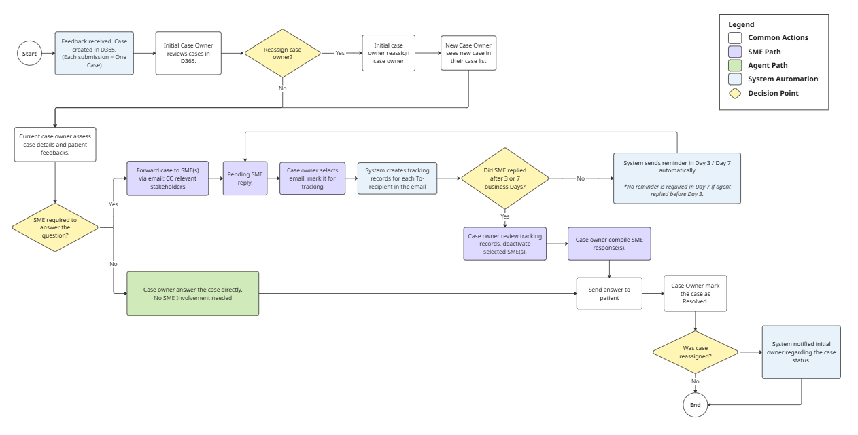 TO-BE User Journey - Overview
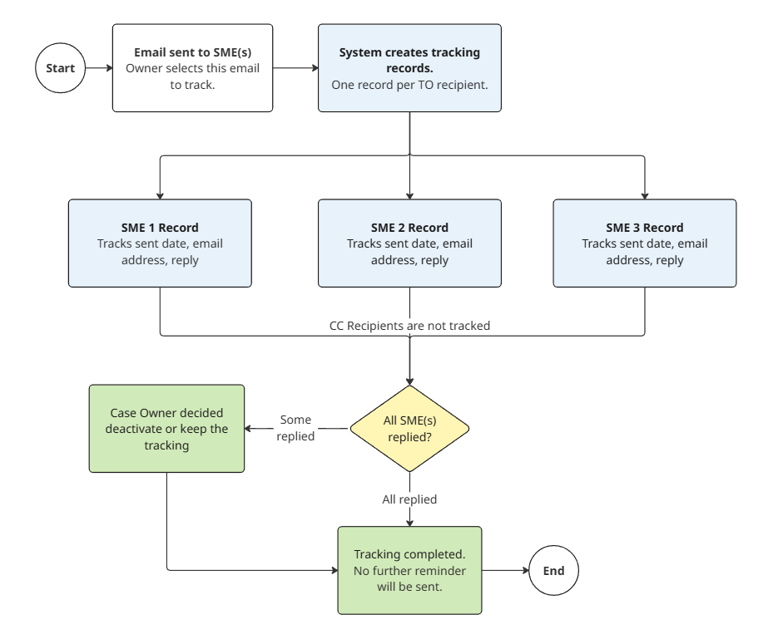TO-BE User Journey – SME Tracking
- Patient submits a case via Email, Web Form, or WhatsApp
- A new case is created in CRM and assigned to the case owner automatically.
- The Initial Case Owner reviews the case details.
- The Initial Case Owner reviews their case list manually, check if reassignment is needed.
- If reassignment is required (cases belongs to another business unit): The initial case owner changes the case owner to the appropriate team. The new case owner sees the case in their list.
Note: The initial case owner loses visibility of the case.
- If no reassignment required: The initial case owner retains the case and proceed.
- Current case owner evaluates if Subject Matters Expert (SME) is required to answer the patient’s question.
5A. SME Path – SME is required:
- Case owner forwards the case to the relevant SME(s) via email. Manager is CC-ed in the email correspondence
Email Tracking Mechanism
- Case owner selects the email to enable tracking.
- The system automatically creates a tracking list based on all TO-recipients
- Each recipient has an individual tracking record,
- SLA tracking is based on the email sent date.
- The system monitors whether each SME has replied, automatically send reminder email when the SLA breaches.
- CC recipients are not tracked.

Tracking Control
- Case owner can decide to deactivate tracking for specific SME(s) once one of them have replied or continue tracking until all SME(s) have responded.

SME Response(s)
- Case owner awaits the SME’s reply.
- Once the SME replies, the case owner compile response(s) and reply to the patient.

5B. Agent Path – SME is NOT required:
  - Case owner answers the patient's question directly without SME involvement.
- The system automatically sends reminders to track for SME reply at Day 3 and Day 7 to chase responses.
- A case is marked Resolved upon confirmation of resolution by the case owner.
- If the case was reassigned, the initial case owner is notified upon case closure.
- Subsequent email responses related to a resolved case are allowed; the status will be automatically updated to ‘In Progress’. The case owner who previously resolved the case will be notified.

System Components

Dynamics 365 Customer Service (D365)
Dynamics 365 serves as the single source of truth. All case states, follow-up indicators, SLA calculations, and reporting are derived from CRM rather than Excel or email threads.
Responsibility
  - Case lifecycle management
  - Case ownership and assignment
  - Follow-up tracking
  - SLA status calculation
  - Audit trail and historical tracking

Power Automate
Power Automate acts as an event-driven automation engine that orchestrates case updates and notifications based on system events and time-based triggers.
Responsibilities
- Case creation from email
- Agent Reply detection
- 3-day and 7-day reminders
- Escalation handling
- Status synchronization
- Post-resolution handling (reopen / notify)

Shared Mailbox
Inbound/outbound communication source
Usage
- Case Assignment emails
- Agent Reply detection source
- Monitoring and trigger source for Power Automate flows

Functional Requirements

CM-02 – Automated Case Tracking & Reminder System

Feature Overview
Problem
The case management system lacks overall status tracking and visibility. Case follow-ups are managed manually in Excel, including:
- Case ID
- Name
- Patient Contact Number
- Patient Email
- Assigned Agent
- CC Name
- Case Type
- Category
- Assigned Date Email Sent
- Next 3 working days Remark
- Agent Reply (Yes or No)
- Next 7 working days
- Date Case Resolved
- Action Taken/ Remarks
This process is inefficient and susceptible to mistakes. Case owners lack real-time visibility into response status and do not have access to automated SLA tracking or reminders.

Proposed Solution: Implement a CRM-based Case Action Log within Dynamics 365 as the single source of truth, supported by Power Automate workflows to automatically
- Track assignment and last action
- Detect agent replies
- Calculate follow-up deadlines (3/7 business days)
- Trigger reminders
- Maintain audit trail
Excel tracking will be fully decommissioned.

System Design Approach
    - Dynamics 365 (System of Record)
Enhance Case entity with custom fields to store CRM data on CRM automatically.

    - Power Automate
Power Automate will serve as the orchestration and enforcement layer for case governance. It ensures SLA timelines are system-calculated, follow-ups are automatically monitored, and CRM remains the single source of truth.
The automation will be event-driven and scheduled, reducing reliance on manual tracking and minimising the risk of SLA breaches.
Event-driven flows will:
- Create/update cases tracking: Ensure SLA tracking begins immediately and consistently for every case without manual setup. Elimination of subjective or inconsistent follow-up practices for post-resolution replies.
- Monitor shared mailbox and detect replies: Automatically detect and track agent follow-up emails to patients before SLA breach, eliminating manual Excel updates and preventing false overdue alerts when engagement has already occurred.
- Calculate business day deadlines: The system automatically calculates SLA timelines (i.e., 3 and 7 business days) upon case creation or reassignment, excluding weekends and public holidays, ensuring every case is governed by a structured and consistent tracking framework from the start.
- Send reminders: Provide proactive notification before SLA breach and enforce accountability through structured escalation.
- Automatically update CRM: Cases breaching SLA or resolved are updated in the system, giving agents a real time dashboard overview of their SLA compliance status, overdue indicator and case volume per agent.

Functional Requirements

Flow 01 – Tracking Record Creation for selected Email
Purpose: This enhancement enables the case owner to select an outgoing email for tracking. Upon selection, the system automatically creates tracking records for each recipient and initiates SLA monitoring.
Trigger: Case owner selects "Track" in the email options within Case Management System or Outlook.
System Behaviour:
When triggered, the system shall:
        - Captures the following details from the selected email:
          - Case ID,
          - Email Sent Date,
          - To recipient’s email address
          - CC recipients’ email address
        - Create a tracking record for each TO recipient. Each record is assigned a tracking ID.
        - Record case details, including To and CC recipients and remarks, within Dynamics 365 on the Agent Tracking page.
        - Populate:
  - Tracking ID
  - Assigned Agent Name
  - CC-ed Name
  - Assignment Date = current date/time, Now()
  - Assigned Agent Email Address
- Agent sends assignment via Teams Channel
- Store and display all tracking records under the
  - “Agent Tracking” tab in the case record
  - Presented in a grid/table view.
Acceptance Criteria:
  - Only selected email will be tracked
  - Only “TO Recipients” are included in tracking
  - “CC recipient” are not tracked
  - One tracking record is created per recipient
  - SLA tracking starts immediately upon email sent
  - Tracking records are automatically linked to the Case ID
Agent Tracking Table (UI Display)
Tracking records shall be displayed in a grid with the following fields.
Field | Type | Purpose
Record ID | Hyperlink | System-generated record ID. Users may click the link to view or update the case details to ensure accurate case information and recipient notifications. Not editable.
Case ID | String | System-generated case reference ID created when the case is first logged. Used as the primary reference for the case. Not editable.
Name | Text | Name of the patient associated with the case. This information is part of the case details. Not editable.
Patient Contact Number | Text | Contact number of the patient. Part of the case details and may be updated if required.
Patient Email | Text | Email address of the patient. Part of the case details and may be updated if required.
Assigned Agent | Text | The agent responsible for responding to the case. The system tracks whether the assigned agent replies within the defined SLA timeline. Users may update the recipient by opening the record via the Record ID link and switching to editable mode.
CC Name | Text | Additional recipient(s) copied when the case is forwarded. Users may update the recipients by opening the record via the Record ID link and switching to editable mode.
Case Type | Text | Indicates the type of case (e.g., enquiry, feedback, complaint). Users may update this field in editable mode.
Category | Text | The classification category of the case for reporting and tracking purposes. Users may update this field in editable mode.
Assigned Date / Email Sent | DateTime | The date when the case was forwarded to the assigned agent. This date serves as the start of the SLA tracking period.
Next 3 Working Days Remark | Text | A view-only field displayed in the grid table to show remarks recorded within the first 3 working days.  Users can click on the Record ID to access the editable form, where they can enter or update the remarks. Once saved, the updated remark will be reflected in the grid table for tracking and visibility.
Agent Reply (Yes/No) | Yes/No | Indicates whether the assigned agent has replied within 3 working days after the case was forwarded. The system monitors the agent’s mailbox to detect replies. If a reply is detected, reminders are not sent and further monitoring for Day 7 is not required.
Next 7 Working Days | Yes / No / Blank | Indicates whether the assigned agent (who did not reply within the first 3 working days) replied within 7 working days after the case was forwarded. If the agent replied within Day 3, this field remains blank.

Flow 02 – Agent Reply Detection
Description: System sends automated reminders when no reply is detected.
Trigger:
- No reply after 3 business days
- No reply after 7 business days
System shall:
- Monitor incoming emails
- Match Case Number from subject/thread
- Validate recipient email against tracking agent’s email
- Update:
      - Agent Reply = Yes
      - Last Action Date = current date/time, Now()
- Stop pending reminders

Acceptance Criteria
- The system shall send notifications only when Reply Status = No and Tracking Status = Active.
- The system shall immediately stop all SLA monitoring and reminder notifications when:
  - Agent Reply = Yes OR
  - Tracking record is manually deactivated tracking for specific recipient.
    - User required to click “Deactivate” button on Agent Tracking Tab for the selected user.
    - This action stops monitoring only and does not indicate that a response has been received.
    - Once deactivated, the tracking record will be removed from the tracker list.
    - Audit Log will retain the full tracking record.

Flow 03 – SLA Reminder Tracking (3 / 7 Business Days)
Description: This flow governs the ongoing tracking of To-recipient’s responses, including SLA calculation, reminder triggering, escalation, and system logging.
Trigger:
- Triggered after tracking records are created (Flow 1)
- Runs on a scheduled basis (e.g., every 1 hour via Power Automate)

SLA Definition:
  - 3 Business Days – First follow-up
  - 7 Business Days – Escalation
System shall:
        - Query active cases where
  - Agent Reply = No
  - and Agent Email Address
    - Calculate business day difference between current date and Assignment Date
    - If no reply detected after:
- SLA 1: Automatically send reminder to the agent (e.g., 3 Business Days).
Example:
Recipient: Assigned Agent via Teams
Subject: Reminder: Follow-up Required – Case [Case ID]
Content: Include case summary, patient details, and direct CRM link
CRM Frontend Interface: Display case as Overdue (Refer Section 8.3.2.1)

- SLA 2: Automatically end reminder to the agent (e.g., 7 Business Days).
Example:
Recipient: Assigned Agent, BU Manager/Lead
Subject: Reminder: Follow-up Required – Case [Case ID]
Content: Include case summary, patient details, and direct CRM link
CRM Frontend Interface: Display case as Overdue (Refer Section 8.3.2.1)
- Log reminder date & status in CRM
  - Reminder Type (3D / 7D)
  - Reminder Sent Date
  - Escalation Indicator
  - System-generated activity record in Case Timeline
All messages will use standardised templates to ensure consistent and clear communication. Refer to Section 9 for Notification template.
Acceptance Criteria
- Reminders triggered accurately if no reply after 3 and/or 7 business days only
- If the agent replies within 3 business days, no reminder is sent.
- If there is still no reply by 7 business days, trigger a second reminder.
- Only business days (excluding weekends and public holidays) are counted for SLA.
- No duplicate reminders are sent for the same SLA milestone.
- All reminders and escalations are logged in the CRM.
- SLA is calculated from case assigned date to current date.

Type of Notification Scenarios
Scenario | Tracker Created | Day 3 Reminder | Day 7 Reminder
Email to Multiple SMEs | Yes (per recipient) | Sent only to non-responders via Teams (team channel) + Email | Final reminder via Teams (team channel) + Email
Email to Single SME | Yes | Sent via Teams (team channel) + Email | Final reminder via Teams (team channel) + Email
Assigned to Seat Agent(s) | Yes | Sent via Teams (team channel) + Email | Optional escalation
Email without Tracking | No | No | No
Note: Sent to Email only if SME/recipient has no Teams account

Scenario 1 — Forward Case to Multiple SMEs (Tracking Required)
Example: Contact Team forwards the email to 3 SMEs and enables tracking.
Tracker Creation
- Follow-Up Trackers are created for the case.
- One tracker per SME is created in Dataverse.
- Trackers should be visible in the case UI under Agent Tracking tab.

Daily Monitoring
Power Automate runs a daily scheduled job to check reply to status.

Scenario A — All SMEs Reply Within 3 Days
For each SME:
- Agent Reply = True
- No reminder sent
- Tracker stops monitoring
- No further reminders are triggered

Scenario B — Partial SMEs Reply Within 3 Days
SME who replied
- Agent Reply = True
- No reminder sent
- Tracker stops monitoring for that SME
SME who did not reply
- Agent Reply = False
- Reminder sent via:
  - Teams Notification
  - Email
- Tracker continues monitoring until Day 7

Scenario C — Replies Checked on Day 7
SME who replied before Day 7
- Agent Reply = True
- No reminder sent
- Tracker stopped
SME who still has not replied after 7 Days
- Agent Reply = False
- Final reminder sent via:
  - Teams Notifications
  - Email

Scenario D — SME Did Not Reply After Day 7
- Tracker status updated Agent Reply = False
- No further reminders triggered

Scenario 2 — Forward Case to Single SME (Tracking Required)
Tracker Creation
- ONE tracker record is created for the SME.

Day 3 Check
If SME replied
- Agent Reply = True
- No reminder sent
- Tracker stops monitoring
If SME did not reply
- Agent Reply = False
- Reminder sent via:
  - Teams Notification
  - Email
- Tracker continues monitoring until Day 7

Day 7 Check
If SME replied
- Agent Reply = True
- Tracker stopped
- No further reminders
If SME did not reply
- Agent Reply = False
- Final reminder sent via:
  - Teams Notification
  - Email
- Tracker closed. No further monitoring.

Scenario 3 — Assigned Case to Another Non-SME Agent (Tracking Required)
Process
- Case is assigned to a new agent
- A tracker record is created
Monitoring
- Power Automate checks if the agent responds the case.
If no activity detected
- Reminder sent via Microsoft Teams notification

Scenario 4 — Email Without Tracking required
If tracking is not required:
- Email is sent normally
- No tracker record is created
- No reminders or monitoring in Day 3/7

CM-03 – Post-Resolution Reply Detection

Feature Overview
Problem
Patient’s replies received after a case is marked resolved may go unnoticed, resulting in missed follow-ups. Currently, agents must manually monitor the email inbox and locate the corresponding case in the Case Management System in order to mitigate the risk.

Proposed Solution
Automatically detect post-resolution replies and notify responsible parties or reopen the case.

Power Automate continuously monitors inbound mailbox and validates case status.
- Continuous mailbox monitoring via Power Automate
- Detection of incoming emails linked to resolved cases
- Automated notification and optional case reopening
- If email received for resolved case:
  - Alert assigned agent
  - Notify manager
  - Option to reopen case automatically

High-Level Process Flow
- Incoming email detected – Power Automate monitors the mailbox for all new messages.
- Case matched – The system matches the email to the corresponding case in Dynamics 365.
- Post-resolution check – If the case status is Resolved:
  - Notify the last assigned case owner via Teams
  - Notify the manager for visibility via Teams
  - And provide the agent with the option to reopen the case or retained the status.

Functional Requirements

Flow 04 – Post-Resolution Reply Handling
Estimated Man Days: 7 Days
Trigger: Incoming external email in shared mailbox for Resolved case
System shall:
- Parse Case Number / Email Subject
  - Parse incoming email for Case Number or relevant subject line reference.
  - Match the email to the corresponding case in Dynamics 365.
    - Check Case Status – A decision point determines whether the case is already resolved. If not, no further action is taken.
    - If Case Status = Resolved
      - Notify the previous assigned case owner via Teams Channel about the incoming post-resolution reply.
      - Automatically reopen the case to “In Progress”
      - The case owner may manually update the case status to “Resolved” if required.
    - Update audit log

Acceptance Criteria
- Audit captures all flow activities
- Assigned agent and relevant stakeholders are notified
- Reopening of resolved cases is optional and tracked.

Notification Message Template
Email Sent to Case Owner
Notification Channel: | Email
Recipient: | Last Case Owner (who marked the case as Resolved)
Subject: | New Response Received for Case [Case ID]
Message: | Hello [Owner Name],  A new response has been received for Case [Case ID], which was previously marked as resolved. The case has now been automatically reopened and its status updated to In Progress.  Case Details:  - Patient Name: [Name]  - Case Type: [Case Type]  - Category: [Category]  - Previous Resolution Date: [Resolved Date]  Please review the latest response and take the necessary follow-up action.  [CRM Case Link]  Thank you.  Case Management System  This is an automated notification generated by the system.

Teams Sent to Case Owner
Notification Channel: | Teams
Recipient: | Last Case Owner (who marked the case as Resolved)
Message: | Case Reopened – Action Required  A new response has been received for Case [Case ID], which was previously marked as resolved. The case has now been automatically reopened and updated to In Progress.  Patient: [Name]  Case Type: [Case Type]  Category: [Category]  Please review the latest response and follow up accordingly.  [Case Link]

CM-08 – Outstanding Actions Visibility Dashboard

Feature Overview
Problem
Agents and managers lack a clear, real-time view of pending and overdue tasks. To track the status of their cases, agents currently rely on a manually updated Excel worksheet that the contact team maintains on a daily basis.

Proposed Solution
CRM dashboards and views with outstanding action indicators.
Use calculated fields, views, and dashboards.

Functional Requirements

New Page/Table 01 – SLA Indicators & Dashboards
Estimated Man Days: 5 Days
System shall:
- Calculated fields:
  - Days since last action
  - SLA countdown
  - Overdue flag
- New “Outstanding Cases” page
  - My Pending Cases – The total unresolved cases assigned to the Seat agent, including those both within and outside SLA.
  - Overdue Cases: Cases without agent response after 3 and 7 days. Sum of SLA 1 and SLA 2.
- SLA 1 (3 Days): Cases that exceed the 3-day SLA and are awaiting an agent response.
  - SLA 2 (7 Days): Cases that exceed the 7-day SLA and are awaiting an agent response.

Acceptance Criteria
- Each team sees all the cases assigned to them
- Team BO/Team PSC/Team Clinic Ops can view the cases from each other’s team.
- Team BO/Team PSC/Team Clinic Ops cannot view cases from TMPL and CX.

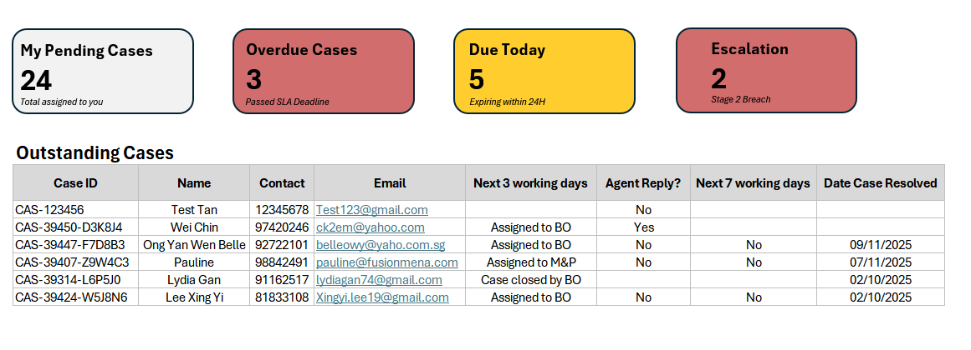
Dashboard Low Fidelity Design

CM-09 – Original Owner Case Visibility

Feature Overview
Problem Statement
When a case is reassigned, the initial case owner loses visibility, which may result in cases being marked as resolved incorrectly or prematurely without proper oversight. To address this, the system will notify the initial case owner whenever a reassigned case is marked as resolved, enabling review and validation of the closure.

Proposed Solution
- Ensure closure visibility for the initial case owner (i.e., the first owner assigned at case creation, regardless of any subsequent reassignments)
- Allow post-resolution case reviews
- Minimize risk of incorrect closures
- Notify stakeholders upon closure for transparency and auditing

Functional Requirements

Flow 05 – Case Closure Notification
Estimated Man Days: 5 Days
Description: This flow ensures that the initial case owner retains visibility of reassigned cases by receiving a notification when the case is marked as Resolved by the current case owner.

Trigger: Case owner marked a case as Resolved
System shall:
- Check if the current owner is not equal to the initial case owner.
  - If the current owner is the initial case owner, flow ends here.
- Retrieve Initial Case Owner stored at the point of case creation.
- Send a notification to the initial case owner via Teams Channel for the following details for the resolved case.
  - Case ID
  - Patient Name
  - Case Type / Category
  - Resolved Date
  - Current Case Owner (Resolved By)
  - Summary / Action Taken
  - Case Link
- Audit log the notification sent

Acceptance Criteria
- Notification is triggered on if
  - Case has been reassigned at least once
  - Initial Case Owner is not the Current Case Owner
  - Case status changes to Resolved
- Initial Case Owner must be:
  - Captured at case creation
  - Stored as a system field (non-editable)

Notification

Notification Mechanism
SLA Reminders and system notifications will be delivered through configured communication channel to ensure timely follow-up and visibility.
Notification Channels
- Microsoft Teams Channel Notification – Notifications/reminders are posted to a configured Microsoft Teams channel associated with the recipient’s team/business unit.
- Email notification – Notifications/reminders are sent to the user’s registered email address.
This serves as a fallback and ensures users are notified even when Teams is unavailable.

Channel Behaviour Rules
- Users with a Microsoft Teams account will receive:
  - Teams channel notification
  - Email notification
- Users without a Teams account (e.g., SME external users) will receive:
  - Email notification only

Teams Channel Configuration
A new configurable field, “Teams Channel”, will be introduced under Team Profile Settings.
Configuration Details
- Admin users can assign a Teams channel to each team/business unit via a dropdown selection.
- The Teams channel mapping is:
  - Fully configurable
  - Can be updated or reassigned at any time by the admin
- If no channel is selected, the field will remain blank

Default Behaviour
- If no Teams channel is configured for a team:
  - Notifications will be sent to a default channel: “General”

Notification Routing Logic
Notification delivery is determined based on how the case is assigned
Note:
- Notifications are routed at the team or business unit level to ensure consistency, with users inheriting visibility based on their assigned team.
- Email serves as a fallback channel in cases where Microsoft Teams is not available.
Assignment Type | Notification Destination
Assigned to Team | Sent to the team’s configured Teams channel
Assigned to Specific User | Sent to the Teams channel of the user’s parent team
User without Teams Account | Email only
No Teams Channel Configured | Sent to default “General” channel

Key Behaviour
- All users within a team inherit the team’s configured Teams channel
- Each team is expected to own and monitor their assigned Teams channel
- This ensures centralised visibility and avoids missed SLA reminders

Notification Message Template

Notify Agent/SME When New Case Is Assigned
New Case Assignment Email Reminder
Notification Channel: | Email
Recipient: | New Case Owner
Subject: | New Case Assigned – Case [Case ID]
Message: | Hello [New Owner Name],  A new case has been assigned to you for handling. Please review the case details and take the necessary action.  Case Details:  - Case ID: [Case ID]  - Patient Name: [Name]  - Case Type: [Case Type]  - Category: [Category]  - Assigned Date: [Assigned Date]  Access Case: [Case Link]  Thank you.  Case Management System  This is an automated reminder generated by the system. Please do not reply to this notification.

New Case Assignment Teams Reminder
Notification Channel: | Teams Channel
Recipient: | New Case Owner
Message: | New Case Assigned  A new case [Case ID] has been assigned to you.  Patient: [Name]  Type: [Case Type]  Category: [Category]  Please review and take action.  [Case Link]

Notify Agent/SME When No Reply After 3 Days
Day 3 No Reply Email Reminder (Tracking Enabled)
Notification Channel: | Email
Recipient: | Tracking-enabled “To” recipient who has No reply after 3 days
Subject: | First Reminder: Response Required for Case [Case ID]
Message: | Hello [Name],  This is a reminder that we have not received your response for Case [Case ID].  Please reply to the email thread to provide your input. If you have already responded, no further action is required.  Thank you.  Case Management System  This is an automated reminder generated by the system. Please do not reply to this notification.

Day 3 No Reply Teams Reminder
Notification Channel: | Teams Channel
Recipient: | Tracking-enabled “To” recipient who has no reply after 3 days
Message: | First Reminder: Case Follow-Up Response Pending  You have not responded to Case [Case ID] yet.  Please review the email and provide your response within 3 days.

Notify Agent/SME When No Reply After 7 Days
Day 7 No Reply Email Reminder (Tracking Enabled)
Notification Channel: | Email
Recipient: | Tracking-enabled “To” recipient who has No reply after 7 days
Subject: | First Reminder: Response Required for Case [Case ID]
Message: | Hello [Name],  This is a final reminder that we have not received your response for Case [Case ID].  Please review the email thread and provide your response. If you have already responded, no further action is required.  Thank you.  Best regards,  Case Management System  This is an automated reminder generated by the system. Please do not reply to this notification.

Day 7 No Reply Teams Final Reminder
Notification Channel: | Teams Channel
Recipient: | Tracking-enabled “To” recipient who has No reply after 7 days
Message: | Final Reminder: Case Follow-Up Response Pending  No response has been received for Case [Case ID].  Please review the email and respond as soon as possible.

Notify Initial Case Owner When Case Is Resolved
Email Sent to Initial Case Owner
Notification Channel: | Email
Subject: | Case Closed Notification – Case [Case ID]
Message: | Hello [Initial Case Owner Name],  The following case, which was previously assigned by you, has been marked as Resolved by another case owner.  Case Details:  - Case ID: [Case ID]  - Patient Name: [Name]  - Case Type: [Case Type]  - Category: [Category]  - Current Case Owner: [Current Owner Name]  - Resolution Date: [Resolved Date]  Thank you.  Case Management System  This is an automated notification generated by the system.

Teams Reminder Sent to Case Owner
Notification Channel: | Teams Channel
Message: | Case Closed (Reassigned Case)  Case [Case ID], previously assigned by you, has been marked as Resolved by [Current Owner Name].  Patient: [Name]  Type: [Case Type]  Category: [Category]

Project Plan
Indicative project timeline as of 20 Feb 2026:
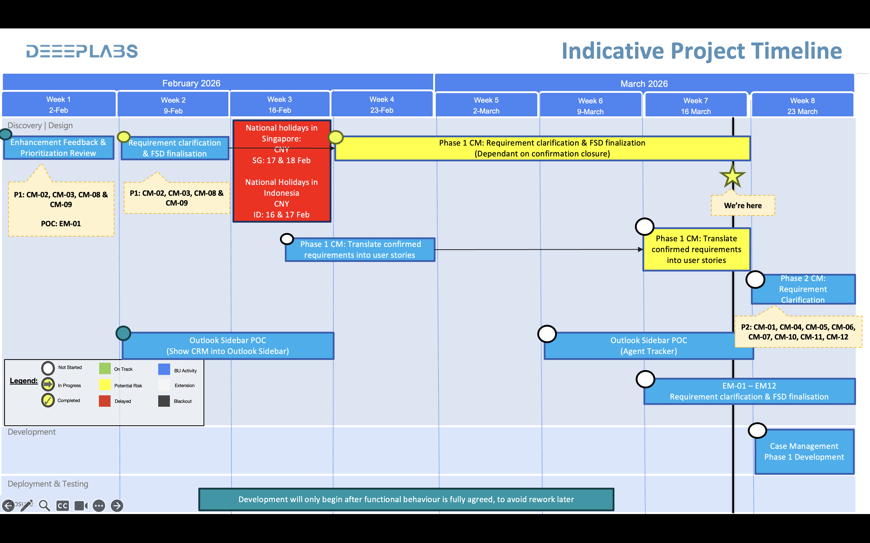
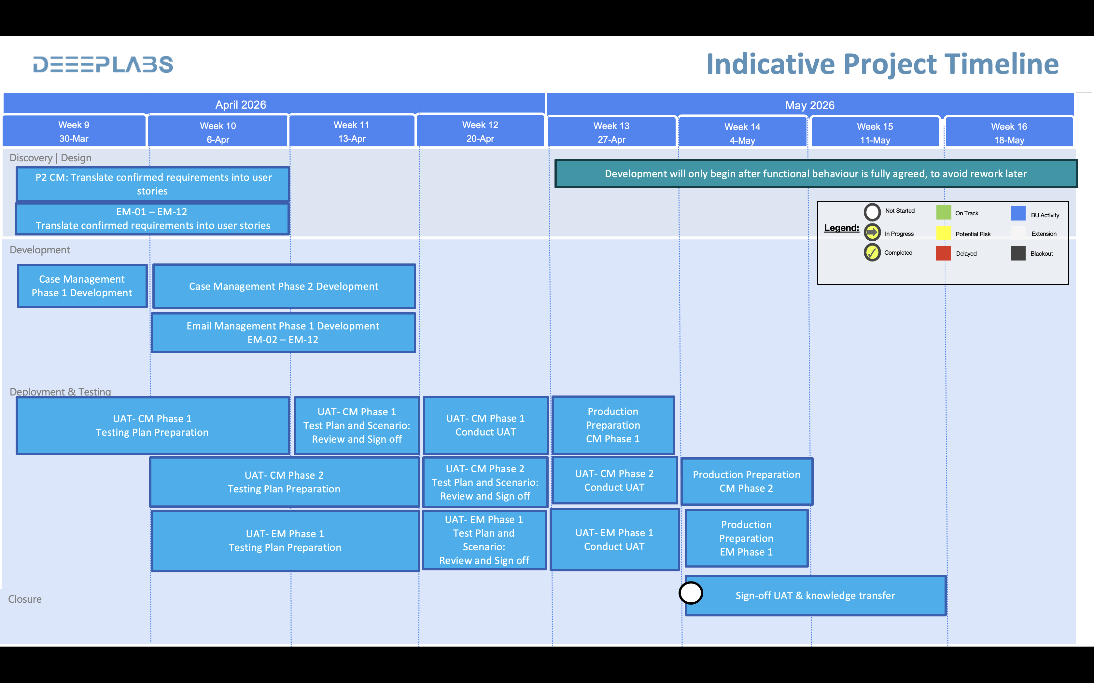
The project is currently in the Discovery and Requirement Clarification phase, focusing on finalising requirements and validating solutions. Key Phase 1 items are being clarified and translated into user stories, alongside an initial Outlook Sidebar POC. Progress in mid‑February was impacted by CNY public holidays in Singapore and Indonesia, which has been factored into the timeline.

